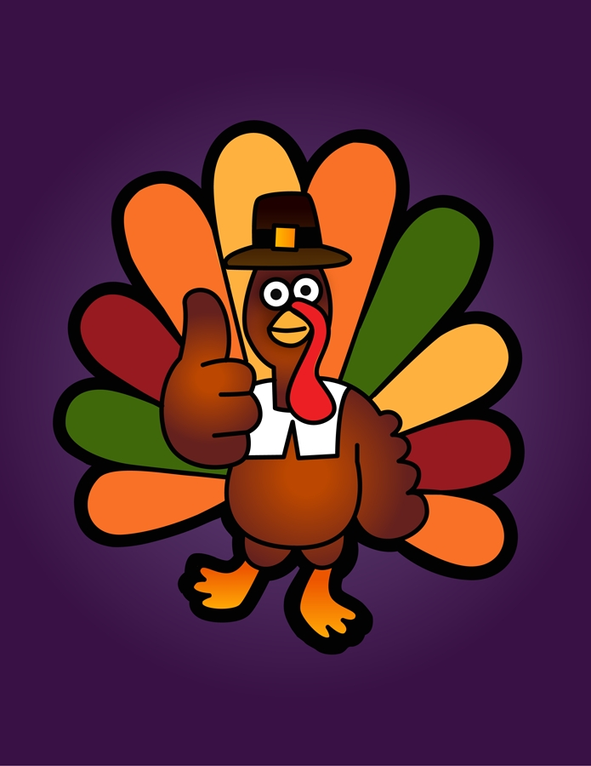

November

MEADOWBROOK BREAKFAST
With Carb Counts

Monday Tuesday Wednesday Thursday Friday
 | 1  CHICKEN BISCUIT 35  OR  BREAKFAST BAR | 2  SAUSGAE DOG  ON-A-STICK 20  OR  BREAKFAST BAR | 3  CHEESE TOAST 16  OR  BREAKFAST BAR | 4  BISCUIT 22 AND GRAVY 9  OR  BREAKFAST BAR
7  SAUSAGE BISCUIT 22  OR  BREAKFAST BAR | 8  PANCAKES 26 W/SYRUP 20  OR  BREAKFAST BAR | 9  FRENCH TOAST STICKS 20  W/SYRUP 20  OR  BREAKFAST BAR | 10  WORKDAY | 11  HOLIDAY
14  SCRAMBLED EGGS 0 W/  TOAST 15  OR  BREAKFAST BAR | 15  CHICKEN BISCUIT 35  OR  BREAKFAST BAR | 16  SAUSGAE DOG  ON-A-STICK 20  OR  BREAKFAST BAR | 17  CHEESE TOAST 16  OR  BREAKFAST BAR | 18  BISCUIT 22 AND GRAVY 9  OR  BREAKFAST BAR
21  SAUSAGE BISCUIT 22  OR  BREAKFAST BAR | 22  PANCAKES 26 W/SYRUP 20  OR  BREAKFAST BAR | 23  HAM AND CHEESE BISCUIT 24  OR  BREAKFAST BAR | 24  CINNI-MINIS 40  OR  BREAKFAST BAR | 25  BISCUIT 22 AND GRAVY 9  OR  BREAKFAST BAR
28  SCRAMBLED EGGS 0 W/  TOAST 15  OR  BREAKFAST BAR | 29  CHICKEN BISCUIT 35  OR  BREAKFAST BAR | 30  SAUSGAE DOG  ON-A-STICK 20  OR  BREAKFAST BAR
Subject to change.
“THIS INSTITUTION IS AN EQUAL OPPORTUNITY PROVIDER.”

