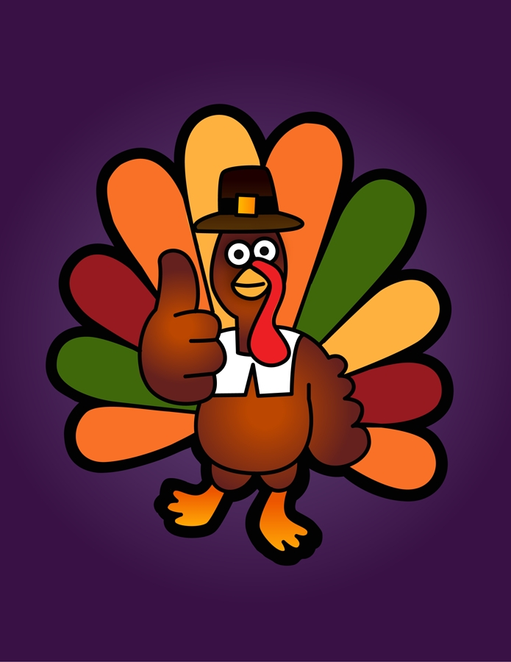

November

ELEMENTARY BREAKFAST

Monday Tuesday Wednesday Thursday Friday
 | 1  CHICKEN BISCUIT  OR  BREAKFAST BAR | 2  SAUSGAE DOG  ON-A-STICK  OR  BREAKFAST BAR | 3  CHEESE TOAST  OR  BREAKFAST BAR | 4  BISCUIT AND GRAVY  OR  BREAKFAST BAR
7  SAUSAGE BISCUIT  OR  BREAKFAST BAR | 8  PANCAKES W/SYRUP  OR  BREAKFAST BAR | 9  FRENCH TOAST STICKS  OR  BREAKFAST | 10  WORKDAY | 11  HOLIDAY
14  SCRAMBLED EGGS W/TOAST  OR  BREAKFAST BAR | 15  CHICKEN BISCUIT  OR  BREAKFAST BAR | 16  SAUSGAE DOG  ON-A-STICK  OR  BREAKFAST BAR | 17  CHEESE TOAST  OR  BREAKFAST BAR | 18  BISCUIT AND GRAVY  OR  BREAKFAST BAR
21  SAUSAGE BISCUIT  OR  BREAKFAST BAR | 22  PANCAKES W/SYRUP  OR  BREAKFAST BAR | 23  ANNUAL  LEAVE | 24  THANKSGIVING  HOLIDAY | 25  HOLIDAY
28  SCRAMBLED EGGS W/TOAST  OR  BREAKFAST BAR | 29  CHICKEN BISCUIT  OR  BREAKFAST BAR | 30  SAUSGAE DOG  ON-A-STICK  OR  BREAKFAST BAR
Subject to change.
“THIS INSTITUTION IS AN EQUAL OPPORTUNITY PROVIDER.”

